BUSINESS PROPOSAL

PT RE-fresh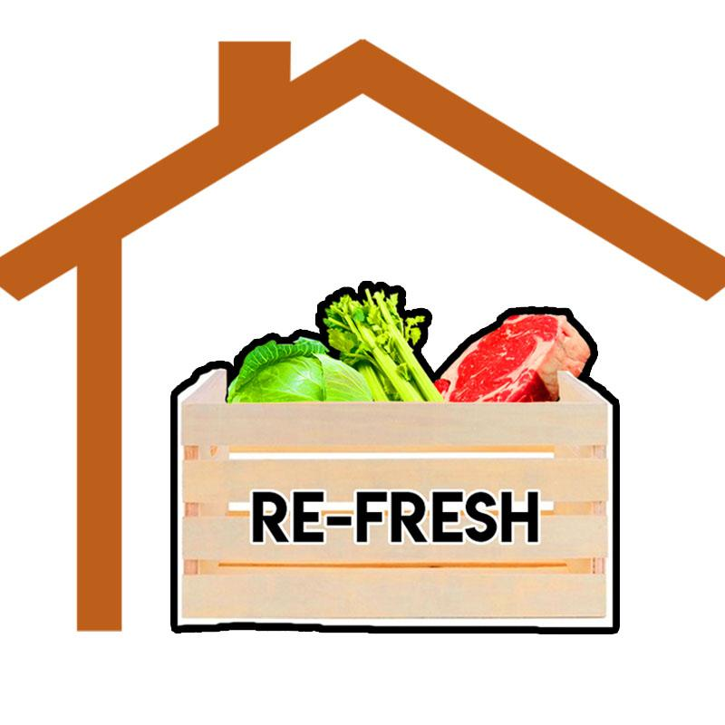

|  |  |
| --- | --- |
| Name | NIM |
| Avery Lenin | 2201741706 |
| Tomy RAS | 2201772415 |
| Jijit Heksa | 2201746884 |
| Rahmannur Rizki S. | 2201751146 |
| Rizky Fajar Nur P. | 2201768941 |

BINUS UNIVERSITY

2019

**I.** **Introduction**

**introduction**

We see an opportunity to create RE-fresh because we want to encourage people so they can cook their own meal which is more healthy and more hygiene and there is not a lot of competitor.

**II.** **Business Description**

**Description**

RE-fresh is an online service that will deliver you fresh and ready to cook ingredients including the recipe on how to cook the ingredients step by step, according to your subscription. These ingredients are handily prepared by our professional chefs to make sure that you get the best ingredients to cook and enjoy at home. Our chefs also made the recipe as easy as possible for you to follow at home so you can make it easier with no problem.

To use our service the customers can go to our website or download our application. After that, they need to sign up and make an account. Then, fill out a form containing personal information and weekly or monthly subscription depend on their need. Only then will we be able to deliver our ingredients and recipes to your houses.

**Goal**

To make it easier to eat healthy and fresh food is essential to ensure our service popularity. By using a subscription-based service, we make sure our customer will never get bored by our selection of fresh and healthy food. To make sure our customer have a great experience, our professional chefs prepare the ingredients and recipes around a theme. This theme creates novels experience for our customer every time they cook our food formulas.

**III. vision and mission**

**Vision**

To be a leading company in providing healthy and fresh food.

**Mission**

· To buy from an authorized farmer company.

· To make sure the ingredient that are sends to our customer are in the best quality.

· To send a recipes from our professional chefs that are easy to follow.

**IV. Swot Analysis**

|  |  |
| --- | --- |
| **Strengths** | **Weaknesses** |
| - We believe that our service is the first and only one available in  Indonesia, thus making it unique and have great potential.  - Our service provides healthy and fresh ingredients with an affordable  price for our customers to enjoy.  - Our service provides a lot of variety of menus that will always get the  customers surprised and excited to wait for their next delivery. | - Since we have to deliver fresh ingredients for our customers, it is hard for us to reach customers who are living outside Jakarta in fear of the ingredients not being fresh anymore. |
| **Opportunities** | **Threats** |
| - Being the first of its kind, we can easily dominate the market share.  - Increasing market growth  - We see potential in modern Indonesian lifestyle where instead of having to go to a restaurant to buy food they order the food online to be delivered to them, our service is perfect for this because the customers doesn’t have to leave the comfort of their home to get the ingredients, instead we deliver the ingredients to them in fresh condition. | - Early customers may not come back after their first purchase, making it hard for us to make profit because we use subscription based services.  - Unstable market may increase the price of ingredients, making our profit decrease since our subscription price is fixed. |

**V. Target Market**

Consumers of our service will be most likely house-wife who wants to be creative with their everyday meal but just doesn’t have the time to come up with something new, and foodie enthusiast who just love food and love to try on new menu every week.

**VI. Marketing Strategy**

We will market our service via online platforms like Facebook, Instagram, YouTube, and also Google Ads.

**Revenue Model**

We charge customer Rp.250,000 each week including shipping with a monthly subscription of Rp.950,000 which is Rp.50,000 cheaper than the weekly subscription. This price is reasonable considering the ingredients are enough for 3 people to consume.

**Estimated Growth First Year**

We are aiming to get 5,000 customers this year.

With 75% of our customers having a monthly subscription, and the rest having the temporary weekly subscription.

**Future Development**

To get as many partners that suits our company so we can reach more customers.

**VII. BUDGET**

|  |  |
| --- | --- |
| **Revenue** | **Expense** |
| **Income**  Rp. 3.875.000.000,00/month  **Total**  Rp. 3.875.000.000,00 | **Routine(month)**  fuel: Rp. 100.000,00 X 15  storage house: Rp.18.333.333,00  staff: Rp. 86.500.000,00  server: Rp. 5.000.000,00  ingredient: Rp. 562.500.000,00  marketing: Rp. 20.000.000,00  **Non Routine**  application: Rp. 20.000.000,00  vehicle: Rp. 6.000.000,00 X 15  **Total**  Routine: Rp. 692.433.333,00  Non Routine: Rp.110.000.000,00 |

**VIII. Conclusion**

Re-fresh is a company that send a food ingredient to your house for you to cook it, our menu is randomized every day so you will not be bored by the food.

**IX. Picture**

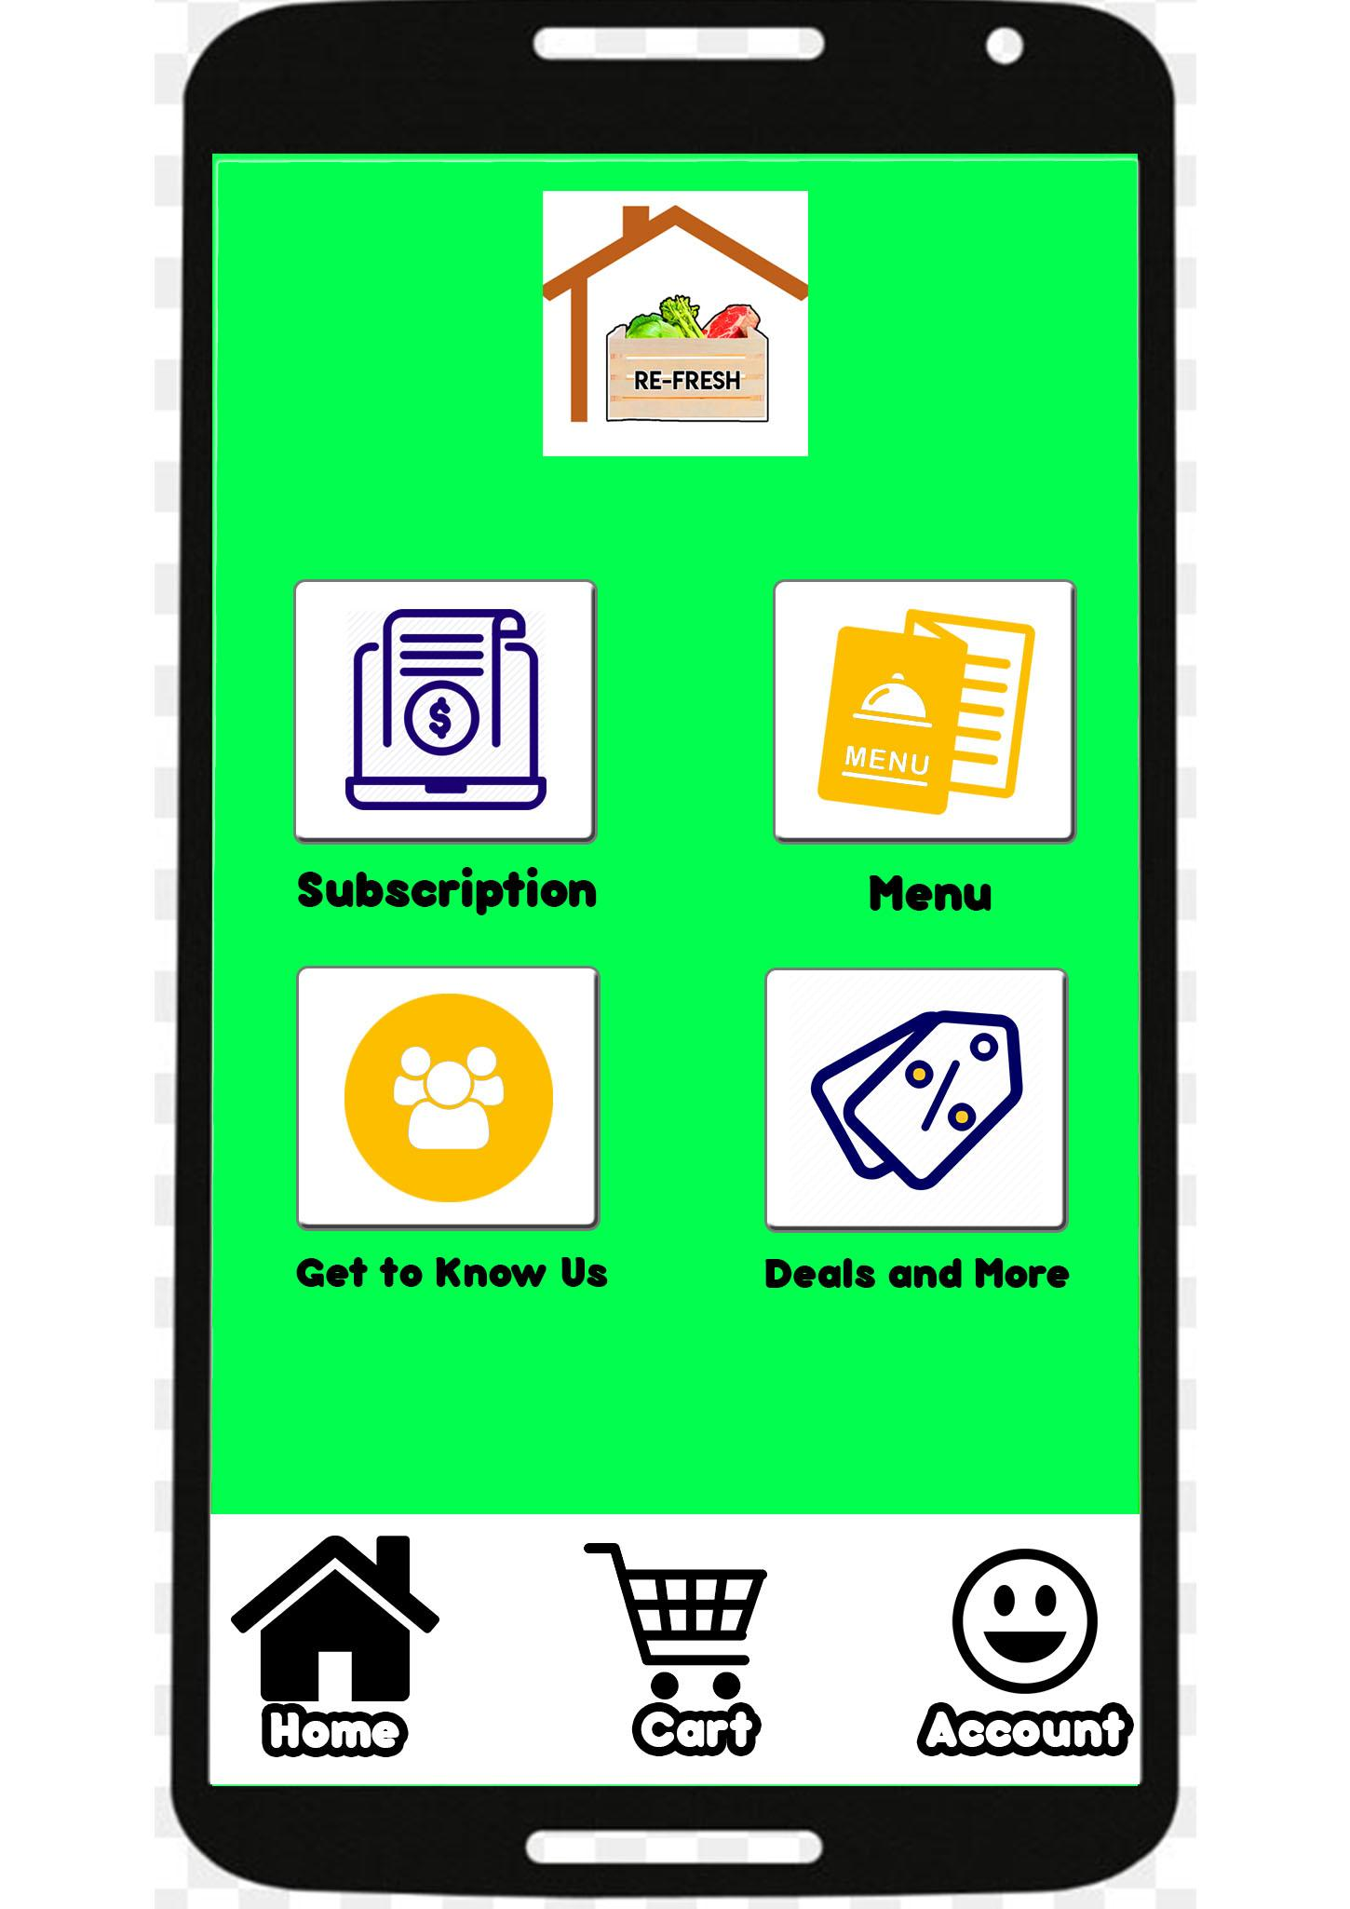

**Picture 1. Interface of our application**

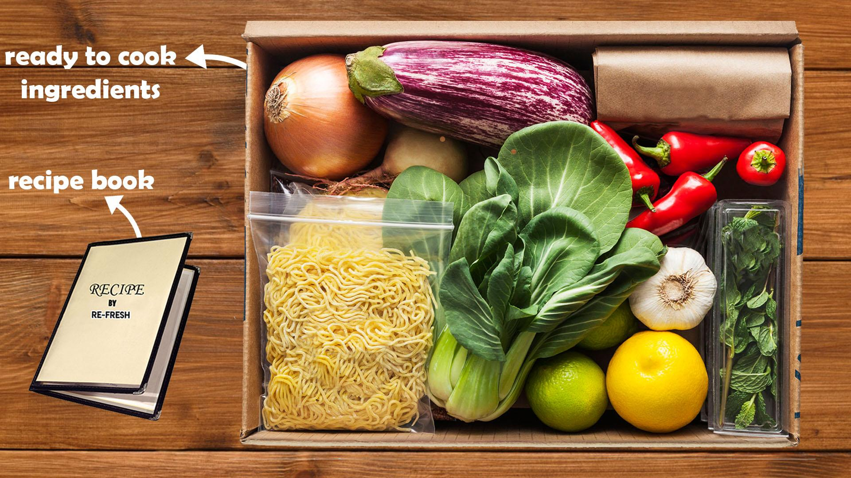

**Picture 2. An illustration of what the customers would get**